**Type casting and Conversions Assignment**

1. Refer the code snippet below perform the operations marked in TBD section, display the results using appropriate format specifier, display results.

#include <stdbool.h>

int main()

{

int i = 123;

short s = 98;

bool b = true;

char c = 'Y';

float d = 235.789;

    //TBD – perform operations below and display result using appropriate format specifier

b+c

s * i

c * d

c = c+b

d = d+c

b = -d

return 0;

}

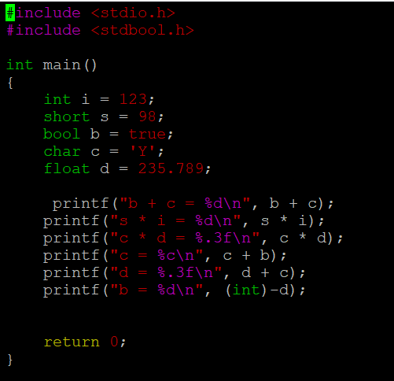

OUTPUT:

